**Final Project Report**

**Woodbridge Church Members Database (WCMD)**

**Kennedy Donkor**

**DBST 651, Fall 2020**

**11/03/2020**

**Statement of Work**

**Overview:**

The Woodbridge Ghanaian Seventh-Day Adventist Church is a local Seventh-Day Adventist church that serves members who are mainly from Ghana and of Ghanaian descent in the Northern Virginia area. They are a community of believers that are seeking to help each other mentally, physically, and spiritually while also serving the community at large. The church is organized into different departments with each department serving a specific role in the church. Currently the departments with its leadership are all recorded manually and distributed to the various departmental leaders. Sometimes it is very difficult to find the members of a department including its leaders especially when one loses the paper copy. This Statement of Work (SOW) will expand on how a database can be created to help solve this problem.

**Executive Summary:**

A database created for Woodbridge Ghanaian Seventh-Day Adventist Church will increase efficiency, productivity, and impact of the church on its members and the community at large.

Creating an electronic database will serve this congregation by helping with the streamline and distribution of information. Projects are delayed or sometimes not implemented at all due to a lack of communication. Having the right information delivered to the concerned party becomes difficult as the members are not sure who is in charge of what. Once this database is setup, it can increase our communication with the respective conference officials in order to take advantage of all the programs available to the church and its community. Not a lot of storage space will be required for the project and the manpower needed to complete this project will be minimal which will bring the cost of the overall project down.

**Objectives:**

This database will help in the construction and maintenance of an online source of information for the immediate retrieval for the members of the church and the community as a whole. Church members will be able to search for different departments using a variety of measures. Using information like the assigned identification for the department, the department name, or one of the members of the department, they should be able to pull up information needed for the department. Once the user pulls up the department of choice, they should be able to access every information about the department including the department leader and the members of the department. The database will be simple enough for even the non-technology savvy individuals to use.

**Project Scope:**

**Include in Project Scope:**

Collecting the data requirements from the church

Gain access to conference information

Installing required software

Creating Business rules

Generating the Entity-Relationship model

Creating the Data Definition Languages (DDL)

Creating the Data Manipulation Language (DML)

Performing data validation checks and the addition of constraints

**Excluded from Project Scope:**

Maintenance of the database

Using systems that are compatible with the database

Database system that is compatible with the conference database

**Database Goals, Expectations, and Deliverables:**

The goal of the database is to organize the departments of the church along with the leaders and the members of the department for easy access. The database is expected to have all the details of each department and its leadership all the way up to the conference level. Having the hierarchy of the departments listed along with their contact information. The deliverables will include the database, the entity-attribute list, the data definition list, the data model, the DDL file.

**Database Benefits:**

Currently there exist no church database. When one wants to find an information for a department, they either have to consult the paper copy which is only made available to the departmental leaders or call someone. This is not very efficient and hinders the progress of the church in terms of decimating information through the proper channels and seeing results in a timely manner or sometimes at all. This will make the information readily available to the concerned department. It will decrease response and implementation time making the church more effective in terms of reaching its members and community. It will decrease misinformation and information getting into the wrong hands by having information delivered to the concerned department directly. It will also increase the communication between the local church departmental leaders and the conference departmental leaders.

**Project Hardware and Software Tools:**

This project will be completed within the Virtual Machine environment provided by University of Maryland Global Campus. The virtual environment will be accessed from a MacBook Air with macOS Catalina version 10.15.6 processor. The virtual environment PC is AUV-UMGCVDA-33. The project will also be using E-R Assistant and Oracle SQL Developer version 19.1.0.094.

**SQL Usage and Style Guide:**

Consistent and descriptive identifiers and names will be used. Example, all names will be descriptive and begin with a letter and if a name is more than one word an underscore will be used. For example, “First Name” will be written as “First_Name”. The ISO 8601 compliant date formation will be used and inputted as YYYY-MM-DD. When comments are use, they will open with /* and close with */. Adequate white space will be used and statements broken up over multiple lines to make it more legible. If a comment is required after a SQL statement then “--“ will be used as the beginning of the comment. Hungarian notations will be avoided along with plurals as much as possible.

**Requirements Definition Document**

**Entity Relationship/Business Rules**

Entity: Position – this refers to the positions that are to be filled in each department by the church members. For each department, there is a director, an assistant director, a secretary, and a treasurer. The PositionID will be created generically to identify the position.

Primary Key: PositionID

Foreign Key: N/A

Relationship: “Holds” between Church Member and Position

Cardinality: 1:M between Position and Church Member

Business Rule: Positions are held by many church members but each position can only be held by one church member. Each position must be held by a church member but not all church members hold positions.

Entity: Church member – this refers to all the members of the church. The MemberID will also be created generically to identify each member. The members name, email address, and phone numbers will also be collected as part of their records and can be used to search for them besides their MemberID. The gender of the church member is also identified for census purposes and what position they hold in the church if any and how long they will be serving in that position.

Primary Key: MemberID

Foreign Key: PositionID and DepartmentID

Relationship: “Belongs” between Church Member and Department

Cardinality: M:N between Church Member and Department

Business Rule: Each church member can belong to many departments and each department can have many church members in them. Each department must have some church members but not all church members belong to a department.

Entity: Department – this refers to all the departments that function in the church. There is a department ID that identifies the department that will also be generically created. Each department has a name and in what capacity they function. The department’s contact information is also made available so everyone knows where they can be reached. In the department’s information is the elder in charge, the conference leader of that department and the members serving in that department.

Primary Key: DepartmentID

Foreign Key: ElderID, ConferenceLeaderID, and MemberID

Relationship: “Oversees” between Department and Elder

Cardinality: 1:M between Elder and Department

Business Rule: One elder can oversee many departments but each department can only be overseen by one elder. A department has to have an overseer and an elder has to oversee a department.

Entity: Elder – these are the selected elders of the church who are to work closely with the church pastor in the running of the church. Their office information and the department or departments that are in charge of are also listed.

Primary Key: ElderID

Foreign Key: DepartmentID

Relationship: “Reports” between Elder and Pastor

Cardinality: 1:M between Pastor and Elder

Business Rule: Many elders can report to the pastor but only one pastor can be reported to. The elders must report to the pastor and the pastor must be reported to.

Entity: Pastor – the pastor serves as the general overseer of the whole church. The pastor’s office information is also collected. The pastor does not have a term limit and therefore that was not included

Primary Key: PastorID

Foreign Key: ConferenceLeaderID

Relationship: “Updates” between Pastor and Conference Leader

Cardinality: 1:M between Pastor and Conference Leader

Business Rule: the pastor updates the many conference leaders of programs being implemented by the departments and the conference leader updates the church pastor of any new programs the conference wants to be implemented. The pastor must update the conference leaders and the conference leaders must update the pastor.

**Entity Relationship Diagram**

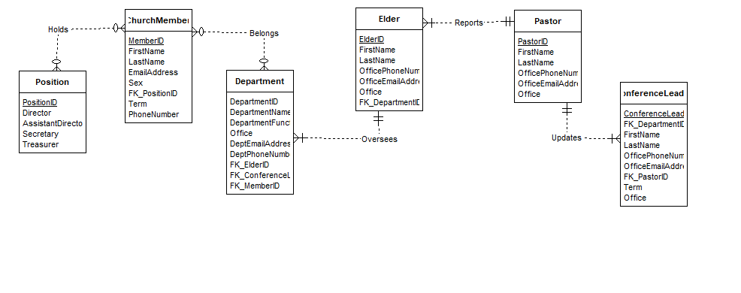

**DDL Source Code**

/*DROP TABLE POSITION CASCADE CONSTRAINTS;

DROP TABLE CHURCH_MEMBER CASCADE CONSTRAINTS;

DROP TABLE DEPARTMENT CASCADE CONSTRAINTS;

DROP TABLE ELDER CASCADE CONSTRAINTS;

DROP TABLE PASTOR CASCADE CONSTRAINTS;

DROP TABLE CONFERENCE_LEADER CASCADE CONSTRAINTS;

DROP SEQUENCE seq_position_id;

DROP SEQUENCE seq_church_member_id;

DROP SEQUENCE seq_department_id;

DROP SEQUENCE seq_elder_id;

DROP SEQUENCE seq_pastor_id;

DROP SEQUENCE seq_conference_leader_id;

*/

--THE TYPE OF POSITIONS IN THE CHURCH THAT CHURCH MEMBERS HOLD--

CREATE TABLE POSITION(POSITION_ID VARCHAR(10) PRIMARY KEY,

DIRECTOR VARCHAR(20) NOT NULL,

ASSISTANT_DIRECTOR VARCHAR(20) NOT NULL,

SECRETARY VARCHAR(20) NOT NULL,

TREASURER VARCHAR(20)

);

--THESE ARE THE BAPTIZED MEMBERS OF THE CHURCH AND SOME HOLD POSITIONS IN DIFFERENT DEPARTMENTS--

CREATE TABLE CHURCH_MEMBER(MEMBER_ID INT PRIMARY KEY,

FIRST_NAME CHAR(20) NOT NULL,

LAST_NAME CHAR(20) NOT NULL,

EMAIL_ADDRESS VARCHAR(20) NOT NULL,

SEX CHAR(1) NOT NULL, -- M or F for census purposes

TERM DATE, --The length of service before the next election cycle

PHONE_NUMBER INT,

POSITION_ID VARCHAR(10), --The position held by the church member

CONSTRAINT FK_MEMBER_POSITION_ID FOREIGN KEY (POSITION_ID) REFERENCES POSITION(POSITION_ID)

);

CREATE INDEX IX_MEMBER_POSITION ON CHURCH_MEMBER(POSITION_ID);

--THE DEPARTMENTS THAT OPERATE IN THE CHURCH--

CREATE TABLE DEPARTMENT(DEPARTMENT_ID INT PRIMARY KEY,

DEPARTMENT_NAME CHAR(20) NOT NULL,

DEPARTMENT_FUNCTION VARCHAR(100) NOT NULL, --The function of the department

OFFICE VARCHAR(5) NOT NULL, --The department's office room number in the church

DEPT_EMAIL_ADDRESS VARCHAR(20) NOT NULL,

DEPT_PHONE_NUMBER INT NOT NULL, --The phone number specifically for the department

ELDER_ID INT, --The elder in charge of the department

CONSTRAINT FK_DEPT_ELDER_ID FOREIGN KEY (ELDER_ID) REFERENCES ELDER(ELDER_ID),

CONFERENCE_LEADER_ID VARCHAR(20),

CONSTRAINT FK_DEPT_CONFERENCE_LEADER_ID FOREIGN KEY (CONFERENCE_LEADER_ID) REFERENCES CONFERENCE_LEADER(CONFERENCE_LEADER_ID),

MEMBER_ID INT, --The members of the department

CONSTRAINT FK_DEPT_MEMBER_ID FOREIGN KEY (MEMBER_ID) REFERENCES CHURCH_MEMBER(MEMBER_ID)

);

CREATE INDEX IX_DEPT_ELDER ON DEPARTMENT(ELDER_ID);

CREATE INDEX IX_DEPT_CONFERENCE_LEADER ON DEPARTMENT(CONFERENCE_LEADER_ID);

CREATE INDEX IX_DEPT_MEMBERS ON DEPARTMENT(MEMBER_ID);

--THE ELECTED ELDERS OF THE CHURCH OVERSEEING DIFFERENT DEPARTMENTS--

CREATE TABLE ELDER(ELDER_ID INT PRIMARY KEY,

FIRST_NAME CHAR(20) NOT NULL,

LAST_NAME CHAR(20) NOT NULL,

OFFICE_PHONE_NUMBER NUMERIC(10) NOT NULL, --the elder's office phone number

OFFICE_EMAIL_ADDRESS VARCHAR(20) NOT NULL, --email address for the office of the elder

OFFICE VARCHAR(5) NOT NULL, --the elders office room number in the church

DEPARTMENT_ID INT); --the department the elder oversees

CREATE INDEX IX_ELDER_DEPT ON ELDER(DEPARTMENT_ID);

--ADDING FOREIGN KEY CONSTRAINT ON AN EXISTING TABLE--

ALTER TABLE ELDER

ADD CONSTRAINT FK_ELDER_DEPARTMENT_ID FOREIGN KEY (DEPARTMENT_ID) REFERENCES DEPARTMENT(DEPARTMENT_ID)

;

--THE CHURCH PASTOR WHO RECEIVES REPORTS FROM THE ELDERS AND UPDATE THE CONFERENCE LEADERS--

CREATE TABLE PASTOR(PASTOR_ID VARCHAR(20) PRIMARY KEY,

FIRST_NAME VARCHAR(20) NOT NULL,

LAST_NAME VARCHAR(20) NOT NULL,

OFFICE_PHONE_NUMBER NUMERIC(10) NOT NULL,

OFFICE_EMAIL_ADDRESS VARCHAR(20) NOT NULL,

OFFICE VARCHAR(5) NOT NULL --the pastor's office room number

);

--THE CONFERENCE LEADERS OF THE DIFFERENT DEPARTMENTS UPDATES THE LOCAL CHURCH PASTORS OF UPCOMING EVENTS--

CREATE TABLE CONFERENCE_LEADER(CONFERENCE_LEADER_ID VARCHAR(20) PRIMARY KEY,

FIRST_NAME VARCHAR(20) NOT NULL,

LAST_NAME VARCHAR(20) NOT NULL,

OFFICE_PHONE_NUMBER NUMERIC(10) NOT NULL,

OFFICE_EMAIL_ADDRESS VARCHAR(20) NOT NULL,

PASTOR_ID VARCHAR(20), --the pastor the conference leader reports to

CONSTRAINT FK_CONFERENCE_LEADER_PASTOR_ID FOREIGN KEY (PASTOR_ID) REFERENCES PASTOR(PASTOR_ID),

OFFICE VARCHAR(6) NOT NULL, --their office in the conference building

DEPARTMENT_ID INT, --the department they are in charge of

TERM DATE --how long they serving for

);

--ADDING FOREIGN KEY CONSTRAINT TO AN EXISTING TABLE--

ALTER TABLE CONFERENCE_LEADER

ADD CONSTRAINT FK_CONFERENCE_LEADER_DEPARTMENT_ID FOREIGN KEY (DEPARTMENT_ID) REFERENCES DEPARTMENT(DEPARTMENT_ID);

CREATE INDEX IX_CONFERENCE_LEADER_PASTOR ON CONFERENCE_LEADER(PASTOR_ID);

CREATE INDEX IX_CONFERENCE_LEADER_DEPT ON CONFERENCE_LEADER(DEPARTMENT_ID);

--THIS WILL SERVE AS A SNAPSHOT OF THE DEPT WITH THE DEPTS BASIC INFORMATION INCLUDING THE ELDER OVERSEEING THAT DEPT--

CREATE VIEW DEPARTMENT_INFO AS

SELECT DEPARTMENT_NAME, OFFICE, DEPT_PHONE_NUMBER, ELDER_ID FROM DEPARTMENT;

--THIS VIEW GIVES THE CHURCH MEMBERS THE OPPORTUNITY TO STAY IN CONTACT WITH ONE ANOTHER--

CREATE VIEW MEMBERS_OF_THE_CHURCH AS

SELECT FIRST_NAME, LAST_NAME, PHONE_NUMBER FROM CHURCH_MEMBER;

--IN CASE A MEMBER NEEDS TO REACH OUT TO CONFERENCE LEADERSHIP, THIS VIEW WILL PROVIDE THAT THEIR INFO--

CREATE VIEW CONFERENCE_INFO AS

SELECT DEPARTMENT_ID, FIRST_NAME, LAST_NAME, OFFICE_EMAIL_ADDRESS FROM CONFERENCE_LEADER;

CREATE SEQUENCE SEQ_POSITION_ID;

CREATE SEQUENCE SEQ_MEMBER_ID;

CREATE SEQUENCE SEQ_DEPARTMENT_ID;

CREATE SEQUENCE SEQ_ELDER_ID;

CREATE SEQUENCE SEQ_PASTOR_ID;

CREATE SEQUENCE SEQ_CONFERENCE_LEADER_ID;

--THE PURPOSE OF THIS TRIGGER IS TO MAKE SURE WHEN A NEW MEMBER IS ADDED TO THE CHURCH, THEY RECEIVE A MEMBER ID--

CREATE OR REPLACE TRIGGER MEMBERID

BEFORE INSERT ON CHURCH_MEMBER

FOR EACH ROW

BEGIN

IF :NEW.MEMBER_ID IS NULL THEN

:NEW.MEMBER_ID := SEQ_MEMBER_ID.NEXTVAL;

END IF;

END;

/

/*ONCE A CHURCH MEMBER IS NO LONGER SERVING IN A POSITION THIS TRIGGER WILL INFORM THE INQUIRER THE MEMBER IS

NO LONGER SERVING IN AN OFFICIAL CAPACITY*/

CREATE OR REPLACE TRIGGER POSITIONID

BEFORE UPDATE ON CHURCH_MEMBER

FOR EACH ROW

BEGIN

IF :NEW.POSITION_ID IS NULL THEN

:NEW.POSITION_ID := 'NO OFFICIAL POSITION';

END IF;

END;

/

/*CHURCH ELDERS ARE ROTATED AFTER A FEW YEARS OF SERVING AND THIS TRIGGER WILL INFORM THE INQUIRER IF

THE ELDER IN QUESTION IS CURRENTLY SERVING*/

CREATE OR REPLACE TRIGGER CHURCH_ELDERS

BEFORE UPDATE ON ELDER

FOR EACH ROW

BEGIN

IF :NEW.ELDER_ID IS NULL THEN

:NEW.ELDER_ID := 'NOT CURRENTLY A SERVIING ELDER';

END IF;

END;

/

SELECT * FROM POSITION;

SELECT * FROM CHURCH_MEMBER;

SELECT * FROM DEPARTMENT;

SELECT * FROM ELDER;

SELECT * FROM PASTOR;

SELECT * FROM CONFERENCE_LEADER;

**DML and Query Source Code**

--Inserting church members information into the database--

INSERT INTO CHURCH_MEMBER(MEMBER_ID, FIRST_NAME, LAST_NAME, EMAIL_ADDRESS, SEX, TERM, PHONE_NUMBER)

VALUES(0001, 'WILL', 'SMITH', 'WILLSMITH@GMAIL.COM', 'M', TO_DATE('01-JAN-21', 'DD-MON-YY'), '5715721111');

INSERT INTO CHURCH_MEMBER(MEMBER_ID, FIRST_NAME, LAST_NAME, EMAIL_ADDRESS, SEX, TERM, PHONE_NUMBER)

VALUES(0002, 'PHILIP', 'BANKS', 'PBANKS@GMAIL.COM', 'M', TO_DATE('01-JAN-21', 'DD-MON-YY'), '5715721122');

INSERT INTO CHURCH_MEMBER(MEMBER_ID, FIRST_NAME, LAST_NAME, EMAIL_ADDRESS, SEX, TERM, PHONE_NUMBER)

VALUES(0003, 'CARLTON', 'BANKS', 'CBANKS@GMAIL.COM', 'M', TO_DATE('01-JAN-21', 'DD-MON-YY'), '5715721123');

INSERT INTO CHURCH_MEMBER(MEMBER_ID, FIRST_NAME, LAST_NAME, EMAIL_ADDRESS, SEX, TERM, PHONE_NUMBER)

VALUES(0004, 'VIVIAN', 'BANKS', 'VBANKS@GMAIL.COM', 'F', TO_DATE('01-JAN-21', 'DD-MON-YY'), '5715721124');

INSERT INTO CHURCH_MEMBER(MEMBER_ID, FIRST_NAME, LAST_NAME, EMAIL_ADDRESS, SEX, TERM, PHONE_NUMBER)

VALUES(0005, 'HILLARY', 'BANKS', 'HBANKS@GMAIL.COM', 'F', TO_DATE('01-JAN-21', 'DD-MON-YY'), '5715721125');

INSERT INTO CHURCH_MEMBER(MEMBER_ID, FIRST_NAME, LAST_NAME, EMAIL_ADDRESS, SEX, TERM, PHONE_NUMBER)

VALUES(0006, 'ASHLEY', 'BANKS', 'ABANKS@GMAIL.COM', 'F', TO_DATE('01-JAN-21', 'DD-MON-YY'), '5715721126');

INSERT INTO CHURCH_MEMBER(MEMBER_ID, FIRST_NAME, LAST_NAME, EMAIL_ADDRESS, SEX, TERM, PHONE_NUMBER)

VALUES(0007, 'NICHOLAS', 'BANKS', 'NBANKS@GMAIL.COM', 'M', TO_DATE('01-JAN-21', 'DD-MON-YY'), '5715721127');

INSERT INTO CHURCH_MEMBER(MEMBER_ID, FIRST_NAME, LAST_NAME, EMAIL_ADDRESS, SEX, TERM, PHONE_NUMBER)

VALUES(0008, 'JEFFREY', 'BUTLER', 'JBUTLER@GMAIL.COM', 'M', TO_DATE('01-JAN-21', 'DD-MON-YY'), '5715721128');

INSERT INTO CHURCH_MEMBER(MEMBER_ID, FIRST_NAME, LAST_NAME, EMAIL_ADDRESS, SEX, TERM, PHONE_NUMBER)

VALUES(0009, 'VY', 'SMITH', 'VYSMITH@GMAIL.COM', 'F', TO_DATE('01-JAN-21', 'DD-MON-YY'), '5715721112');

INSERT INTO CHURCH_MEMBER(MEMBER_ID, FIRST_NAME, LAST_NAME, EMAIL_ADDRESS, SEX, TERM, PHONE_NUMBER)

VALUES(0010, 'HELEN', 'SMITH', 'HSMITH@GMAIL.COM', 'F', TO_DATE('01-JAN-21', 'DD-MON-YY'), '5715721113');

COMMIT;

ALTER TABLE CHURCH_MEMBER ADD POSITION CHAR(30);

DELETE FROM CHURCH_MEMBER WHERE POSITION='DIRECTOR';

UPDATE CHURCH_MEMBER SET POSITION_ID = 'M01' WHERE CHURCH_MEMBER.FIRST_NAME='WILL';

UPDATE CHURCH_MEMBER SET POSITION_ID='T01' WHERE CHURCH_MEMBER.FIRST_NAME='CARLTON';

UPDATE CHURCH_MEMBER SET POSITION_ID='S01' WHERE CHURCH_MEMBER.FIRST_NAME='ASHLEY';

UPDATE CHURCH_MEMBER SET POSITION_ID='Y01' WHERE CHURCH_MEMBER.FIRST_NAME='JEFFREY';

UPDATE CHURCH_MEMBER SET POSITION_ID='CPMO1' WHERE CHURCH_MEMBER.FIRST_NAME='PHILIP';

UPDATE CHURCH_MEMBER SET POSITION_ID='Y01' WHERE CHURCH_MEMBER.FIRST_NAME='NICHOLAS';

UPDATE CHURCH_MEMBER SET POSITION_ID='CPMO1' WHERE CHURCH_MEMBER.FIRST_NAME='VY';

UPDATE CHURCH_MEMBER SET POSITION_ID='CPMO1' WHERE CHURCH_MEMBER.FIRST_NAME='HELEN';

UPDATE CHURCH_MEMBER SET POSITION_ID='T01' WHERE CHURCH_MEMBER.FIRST_NAME='HILLARY';

UPDATE CHURCH_MEMBER SET POSITION_ID='T01' WHERE CHURCH_MEMBER.FIRST_NAME='VIVIAN';

--Inserting conference leaders information into the database--

INSERT INTO CONFERENCE_LEADER(CONFERENCE_LEADER_ID, FIRST_NAME, LAST_NAME, OFFICE_PHONE_NUMBER, OFFICE_EMAIL_ADDRESS, OFFICE, TERM)

VALUES('CT01', 'JAZZY', 'JEFF', '7037301111', 'JJEFF@GMAIL.COM', 'C200', TO_DATE('01-JAN-21', 'DD-MON-YY'));

INSERT INTO CONFERENCE_LEADER(CONFERENCE_LEADER_ID, FIRST_NAME, LAST_NAME, OFFICE_PHONE_NUMBER, OFFICE_EMAIL_ADDRESS, OFFICE, TERM)

VALUES('CS01', 'JACKIE', 'AMES', '7037301112', 'JAMES@GMAIL.COM', 'C201', TO_DATE('01-JAN-21', 'DD-MON-YY'));

INSERT INTO CONFERENCE_LEADER(CONFERENCE_LEADER_ID, FIRST_NAME, LAST_NAME, OFFICE_PHONE_NUMBER, OFFICE_EMAIL_ADDRESS, OFFICE, TERM)

VALUES('CPM01', 'TREVOR', 'COLLINS', '7037301113', 'TCOLLINS@GMAIL.COM', 'C202', TO_DATE('01-JAN-21', 'DD-MON-YY'));

INSERT INTO CONFERENCE_LEADER(CONFERENCE_LEADER_ID, FIRST_NAME, LAST_NAME, OFFICE_PHONE_NUMBER, OFFICE_EMAIL_ADDRESS, OFFICE, TERM)

VALUES('CM01', 'LISA', 'WILKES', '7037301114', 'LWILKES@GMAIL.COM', 'C203', TO_DATE('01-JAN-21', 'DD-MON-YY'));

INSERT INTO CONFERENCE_LEADER(CONFERENCE_LEADER_ID, FIRST_NAME, LAST_NAME, OFFICE_PHONE_NUMBER, OFFICE_EMAIL_ADDRESS, OFFICE, TERM)

VALUES('CY01', 'JANICE', 'SMITH', '7037301115', 'JSMITH@GMAIL.COM', 'C204', TO_DATE('01-JAN-21', 'DD-MON-YY'));

COMMIT;

UPDATE CONFERENCE_LEADER SET DEPARTMENT_ID='100', PASTOR_ID='P100' WHERE CONFERENCE_LEADER.FIRST_NAME='JAZZY';

UPDATE CONFERENCE_LEADER SET DEPARTMENT_ID='200', PASTOR_ID='P100' WHERE CONFERENCE_LEADER.FIRST_NAME='JACKIE';

UPDATE CONFERENCE_LEADER SET DEPARTMENT_ID='300', PASTOR_ID='P100' WHERE CONFERENCE_LEADER.FIRST_NAME='TREVOR';

UPDATE CONFERENCE_LEADER SET DEPARTMENT_ID='400', PASTOR_ID='P100' WHERE CONFERENCE_LEADER.FIRST_NAME='LISA';

UPDATE CONFERENCE_LEADER SET DEPARTMENT_ID='500', PASTOR_ID='P100' WHERE CONFERENCE_LEADER.FIRST_NAME='JANICE';

--Inserting the different departments information into the database--

INSERT INTO DEPARTMENT(DEPARTMENT_ID, DEPARTMENT_NAME, DEPARTMENT_FUNCTION, OFFICE, DEPT_EMAIL_ADDRESS, DEPT_PHONE_NUMBER)

VALUES('100', 'TREASURY DEPT', 'TAKE CARE OF THE CHURCH FINANCES', 'A100', 'TDEPT@GMAIL.COM', '7037302222');

INSERT INTO DEPARTMENT(DEPARTMENT_ID, DEPARTMENT_NAME, DEPARTMENT_FUNCTION, OFFICE, DEPT_EMAIL_ADDRESS, DEPT_PHONE_NUMBER)

VALUES('200', 'SECRETARY DEPT', 'TAKE CARE OF CHURCH RECORDS', 'A200', 'SDEPT@GMAIL.COM', '7037302223');

INSERT INTO DEPARTMENT(DEPARTMENT_ID, DEPARTMENT_NAME, DEPARTMENT_FUNCTION, OFFICE, DEPT_EMAIL_ADDRESS, DEPT_PHONE_NUMBER)

VALUES('300', 'PERSONAL MIN DEPT', 'TAKE CARE OF CHURCH EVANGELISM', 'A300', 'PMINDEPT@GMAIL.COM', '7037302224');

INSERT INTO DEPARTMENT(DEPARTMENT_ID, DEPARTMENT_NAME, DEPARTMENT_FUNCTION, OFFICE, DEPT_EMAIL_ADDRESS, DEPT_PHONE_NUMBER)

VALUES('400', 'MUSIC DEPT', 'TAKE CARE OF EVERYTHING MUSIC RELATED', 'A400', 'MDEPT@GMAIL.COM', '7037302225');

INSERT INTO DEPARTMENT(DEPARTMENT_ID, DEPARTMENT_NAME, DEPARTMENT_FUNCTION, OFFICE, DEPT_EMAIL_ADDRESS, DEPT_PHONE_NUMBER)

VALUES('500', 'YOUTH DEPT', 'TAKE CARE OF THE CHURCH YOUTH', 'A500', 'YDEPT@GMAIL.COM', '7037302226');

COMMIT;

UPDATE DEPARTMENT SET ELDER_ID='1', MEMBER_ID='3' WHERE DEPARTMENT_ID='100';

UPDATE DEPARTMENT SET ELDER_ID='1', MEMBER_ID='6' WHERE DEPARTMENT_ID='200';

UPDATE DEPARTMENT SET ELDER_ID='2', MEMBER_ID='2' WHERE DEPARTMENT_ID='300';

UPDATE DEPARTMENT SET ELDER_ID='2', MEMBER_ID='1' WHERE DEPARTMENT_ID='400';

UPDATE DEPARTMENT SET ELDER_ID='3', MEMBER_ID='8' WHERE DEPARTMENT_ID='500';

--Inserting the church elders information into the database--

INSERT INTO ELDER(ELDER_ID, FIRST_NAME, LAST_NAME, OFFICE_PHONE_NUMBER, OFFICE_EMAIL_ADDRESS, OFFICE)

VALUES(01, 'JOHN', 'JOHNSON', '7037302227', 'ELDER1@GMAIL.COM', 'E101');

INSERT INTO ELDER(ELDER_ID, FIRST_NAME, LAST_NAME, OFFICE_PHONE_NUMBER, OFFICE_EMAIL_ADDRESS, OFFICE)

VALUES(02, 'PETER', 'SAMSON', '7037302228', 'ELDER2@GMAIL.COM', 'E102');

INSERT INTO ELDER(ELDER_ID, FIRST_NAME, LAST_NAME, OFFICE_PHONE_NUMBER, OFFICE_EMAIL_ADDRESS, OFFICE)

VALUES(03, 'JAMES', 'MILLER', '7037302228', 'ELDER3@GMAIL.COM', 'E103');

COMMIT;

UPDATE ELDER SET DEPARTMENT_ID='100' WHERE ELDER_ID='1';

UPDATE ELDER SET DEPARTMENT_ID='200' WHERE ELDER_ID='1';

UPDATE ELDER SET DEPARTMENT_ID='300' WHERE ELDER_ID='2';

UPDATE ELDER SET DEPARTMENT_ID='400' WHERE ELDER_ID='2';

UPDATE ELDER SET DEPARTMENT_ID='500' WHERE ELDER_ID='3';

--Inserting the church pastor’s information into the database--

INSERT INTO PASTOR(PASTOR_ID, FIRST_NAME, LAST_NAME, OFFICE_PHONE_NUMBER, OFFICE_EMAIL_ADDRESS, OFFICE)

VALUES('P100', 'PAUL', 'PETERS', '7037302230', 'CHPASTOR@GMAIL.COM', 'P101');

COMMIT;

--Inserting the different positions that can be held into the database--

INSERT INTO POSITION(POSITION_ID, DIRECTOR, ASSISTANT_DIRECTOR, SECRETARY, TREASURER)

VALUES('T01', 'CARLTON BANKS', 'PHILIP BANKS', 'VIVIAN BANKS', 'HILLARY BANKS');

INSERT INTO POSITION(POSITION_ID, DIRECTOR, ASSISTANT_DIRECTOR, SECRETARY, TREASURER)

VALUES('S01', 'ASHLEY BANKS', 'JEFFREY BUTLER', 'N/A', 'N/A');

INSERT INTO POSITION(POSITION_ID, DIRECTOR, ASSISTANT_DIRECTOR, SECRETARY, TREASURER)

VALUES('CPMO1', 'PHILIP BANKS', 'VY SMITH', 'HELEN SMITH', 'VIVIAN BANKS');

INSERT INTO POSITION(POSITION_ID, DIRECTOR, ASSISTANT_DIRECTOR, SECRETARY, TREASURER)

VALUES('M01', 'WILL SMITH', 'NICHOLAS BANKS', 'ASHLEY BANKS', 'CARLTON BANKS');

INSERT INTO POSITION(POSITION_ID, DIRECTOR, ASSISTANT_DIRECTOR, SECRETARY, TREASURER)

VALUES('Y01', 'JEFFREY BUTLER', 'NICHOLAS BANKS', 'WILL SMITH', 'VY SMITH');

COMMIT;

--Query 1--

SELECT * FROM CHURCH_MEMBER;

--Query 2--

SELECT FIRST_NAME, LAST_NAME, SEX, EMAIL_ADDRESS, PHONE_NUMBER FROM CHURCH_MEMBER;

--Query 3--

SELECT * FROM CONFERENCE_INFO;

--Query 4--

SELECT CHURCH_MEMBER.MEMBER_ID, CHURCH_MEMBER.FIRST_NAME, CHURCH_MEMBER.LAST_NAME, CHURCH_MEMBER.EMAIL_ADDRESS,

CHURCH_MEMBER.SEX, CHURCH_MEMBER.TERM, CHURCH_MEMBER.PHONE_NUMBER, POSITION.POSITION_ID, POSITION.DIRECTOR,

POSITION.ASSISTANT_DIRECTOR, POSITION.SECRETARY, POSITION.TREASURER FROM CHURCH_MEMBER

FULL JOIN POSITION ON CHURCH_MEMBER.POSITION_ID=POSITION.POSITION_ID;

--Query 5--

SELECT * FROM CHURCH_MEMBER ORDER BY LAST_NAME ASC;

--Query 6--

SELECT DEPARTMENT.DEPARTMENT_ID, DEPARTMENT.DEPARTMENT_NAME, ELDER.FIRST_NAME, ELDER.LAST_NAME, CONFERENCE_LEADER.CONFERENCE_LEADER_ID

FROM DEPARTMENT RIGHT JOIN ELDER ON DEPARTMENT.ELDER_ID=ELDER.ELDER_ID

LEFT JOIN CONFERENCE_LEADER ON DEPARTMENT.CONFERENCE_LEADER_ID=CONFERENCE.CONFERENCE_LEADER_ID

FETCH FIRST 10 ROWS ONLY;

--Query 7--

SELECT DISTINCT ELDER.ELDER_ID, ELDER.FIRST_NAME, ELDER.LAST_NAME, DEPARTMENT.DEPARTMENT_ID, DEPARTMENT.DEPARTMENT_NAME, CHURCH_MEMBER.MEMBER_ID FROM ELDER

RIGHT JOIN DEPARTMENT ON ELDER.DEPARTMENT_ID=DEPARTMENT.DEPARTMENT_ID

LEFT JOIN CHURCH_MEMBER ON DEPARTMENT.MEMBER_ID=CHURCH_MEMBER.MEMBER_ID;

--Query 8--

SELECT LAST_NAME, FIRST_NAME, SEX, COUNT(*) FROM CHURCH_MEMBER GROUP BY LAST_NAME, FIRST_NAME, SEX;

--Query 9--

SELECT * FROM ELDER WHERE ELDER_ID IN (SELECT DEPARTMENT.ELDER_ID FROM DEPARTMENT);

--Query 10--

SELECT OFFICE_EMAIL_ADDRESS, LENGTH(OFFICE_EMAIL_ADDRESS) FROM PASTOR;

--Query 11--

DELETE FROM POSITION WHERE DIRECTOR=’PHILIP’;

ROLLBACK;

--Query 12—

UPDATE ELDER SET ELDER.FIRST_NAME=’LUKE’ WHERE ELDER.FIRST_NAME=’JOHN’;

SELECT * FROM ELDER;

ROLLBACK;

SELECT * FROM ELDER;

--Query 13--

SELECT * FROM DEPARTMENT WHERE ELDER_ID=(SELECT ELDER_ID FROM ELDER WHERE ELDER_ID='1');

--Query 14--

SELECT * FROM CONFERENCE_LEADER WHERE PASTOR_ID=(SELECT PASTOR_ID FROM PASTOR);

--Query 15--

SELECT ELDER_ID, MEMBER_ID, DEPARTMENT_NAME, DEPARTMENT_FUNCTION FROM DEPARTMENT ORDER BY DEPARTMENT_NAME DESC;

--Query 16--

SELECT CHURCH_MEMBER.LAST_NAME, CHURCH_MEMBER.FIRST_NAME, (SELECT COUNT(*) FROM CHURCH_MEMBER WHERE LAST_NAME='BANKS') AS FAMILY

FROM CHURCH_MEMBER WHERE LAST_NAME='BANKS' GROUP BY CHURCH_MEMBER.LAST_NAME, CHURCH_MEMBER.FIRST_NAME ORDER BY FIRST_NAME ASC;

--Query 17--

SELECT CHURCH_MEMBER.FIRST_NAME, CHURCH_MEMBER.LAST_NAME, POSITION.POSITION_ID FROM CHURCH_MEMBER

INNER JOIN POSITION ON CHURCH_MEMBER.POSITION_ID=POSITION.POSITION_ID

WHERE POSITION.POSITION_ID='CPMO1' ORDER BY CHURCH_MEMBER.LAST_NAME;

--Query 18--

SELECT CHURCH_MEMBER.FIRST_NAME, CHURCH_MEMBER.LAST_NAME, POSITION.POSITION_ID, DEPARTMENT.DEPARTMENT_ID,

CONFERENCE_LEADER.CONFERENCE_LEADER_ID FROM CHURCH_MEMBER

INNER JOIN POSITION ON CHURCH_MEMBER.POSITION_ID=POSITION.POSITION_ID

INNER JOIN DEPARTMENT ON CHURCH_MEMBER.MEMBER_ID=DEPARTMENT.MEMBER_ID

INNER JOIN CONFERENCE_LEADER ON DEPARTMENT.CONFERENCE_LEADER_ID=CONFERENCE_LEADER.CONFERENCE_LEADER_ID

ORDER BY CHURCH_MEMBER.LAST_NAME ASC;

--Query 19--

SELECT SEX, COUNT(CASE WHEN SEX='M' THEN 1 END) AS MALE, COUNT(CASE WHEN SEX='F' THEN 1 END) AS FEMALE FROM CHURCH_MEMBER

GROUP BY SEX;

--Query 20--

SELECT ELDER.FIRST_NAME, ELDER.LAST_NAME, ELDER.OFFICE_PHONE_NUMBER, DEPARTMENT.DEPARTMENT_NAME, CONFERENCE_LEADER.FIRST_NAME,

CONFERENCE_LEADER.LAST_NAME, CONFERENCE_LEADER.OFFICE_EMAIL_ADDRESS FROM ELDER

INNER JOIN DEPARTMENT ON ELDER.DEPARTMENT_ID=DEPARTMENT.DEPARTMENT_ID

INNER JOIN CONFERENCE_LEADER ON DEPARTMENT.CONFERENCE_LEADER_ID=CONFERENCE_LEADER.CONFERENCE_LEADER_ID

ORDER BY ELDER.LAST_NAME ASC;

**Query Output**

1.

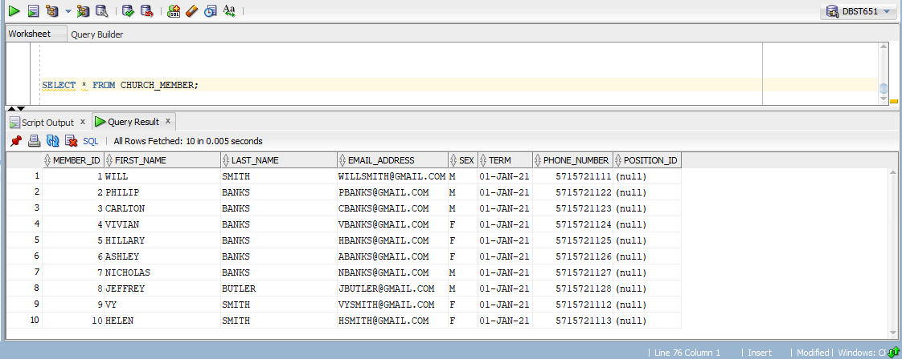

2.

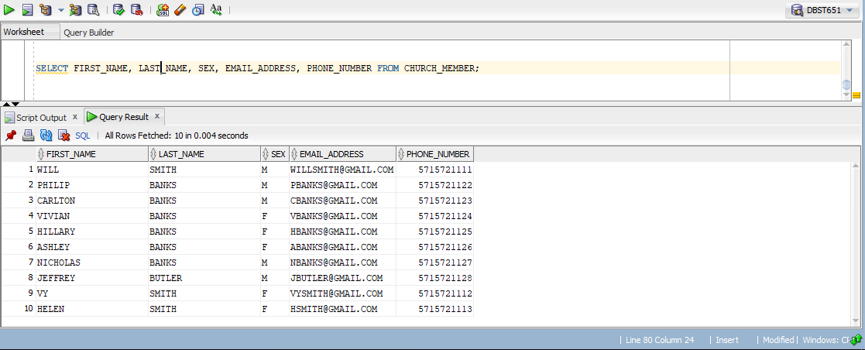

3.

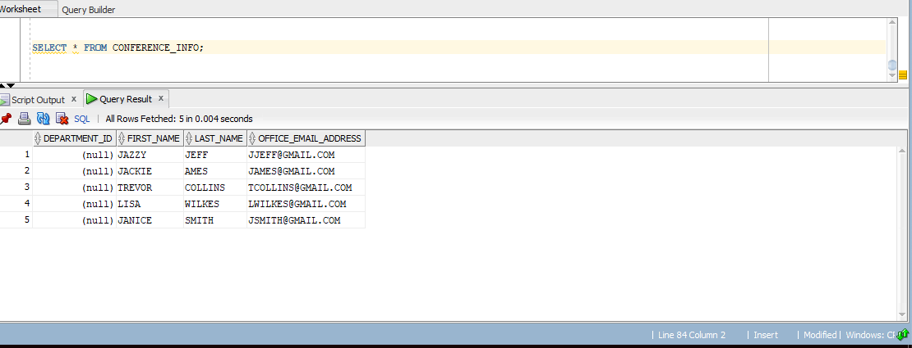

4.

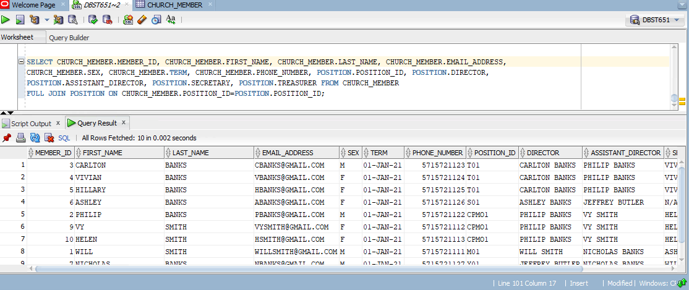

5.

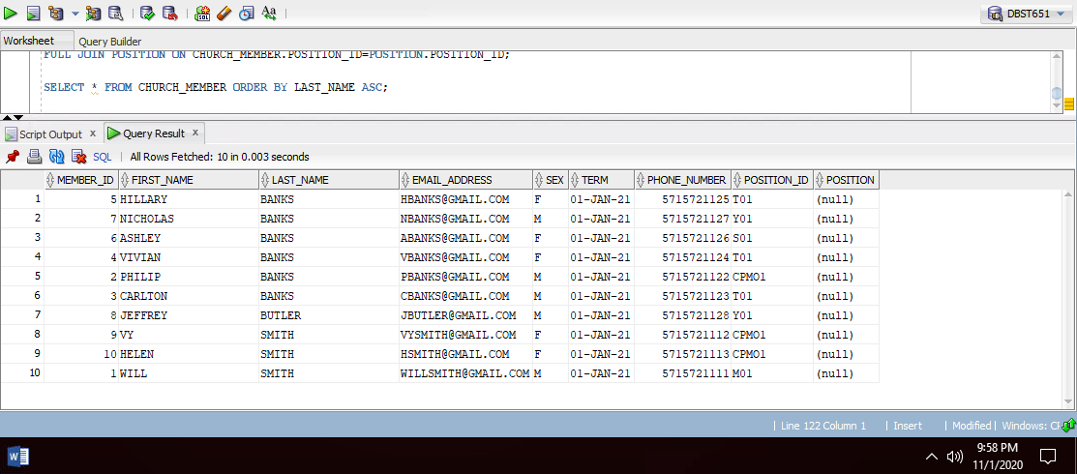

6.

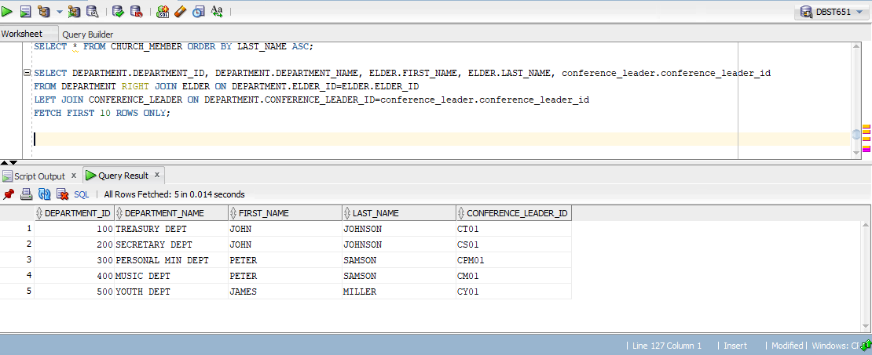

7.

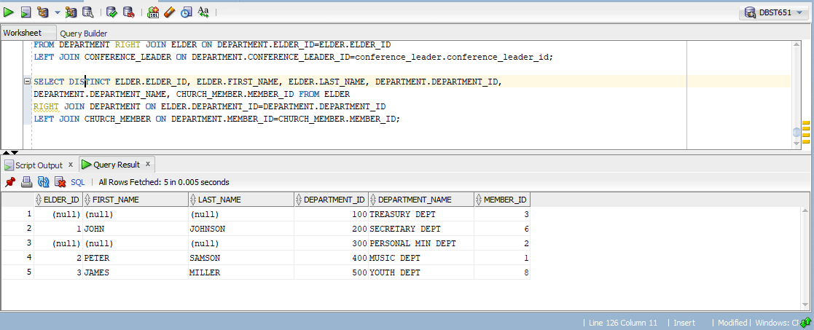

8.

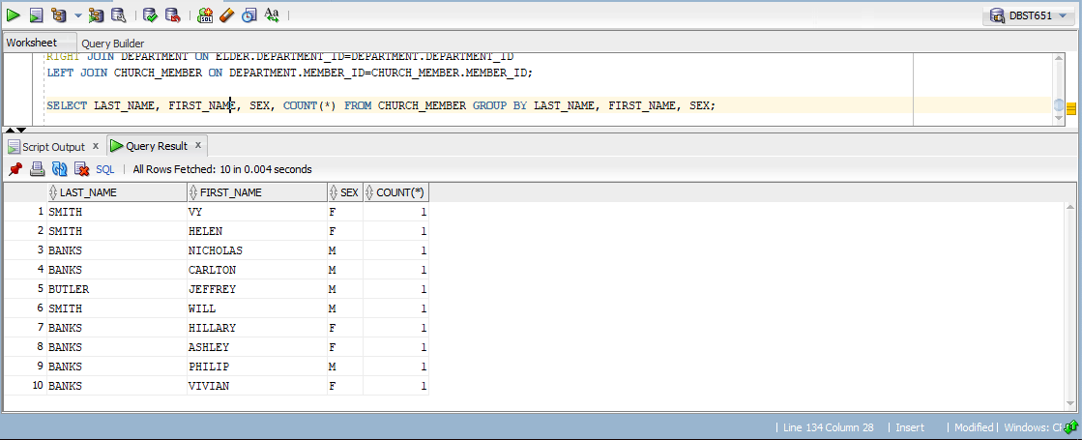

9. 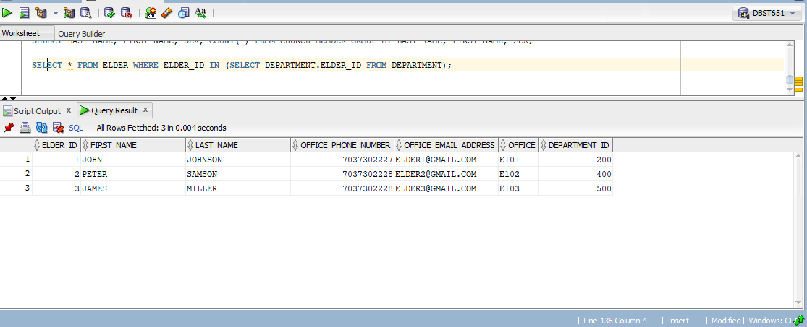

10.

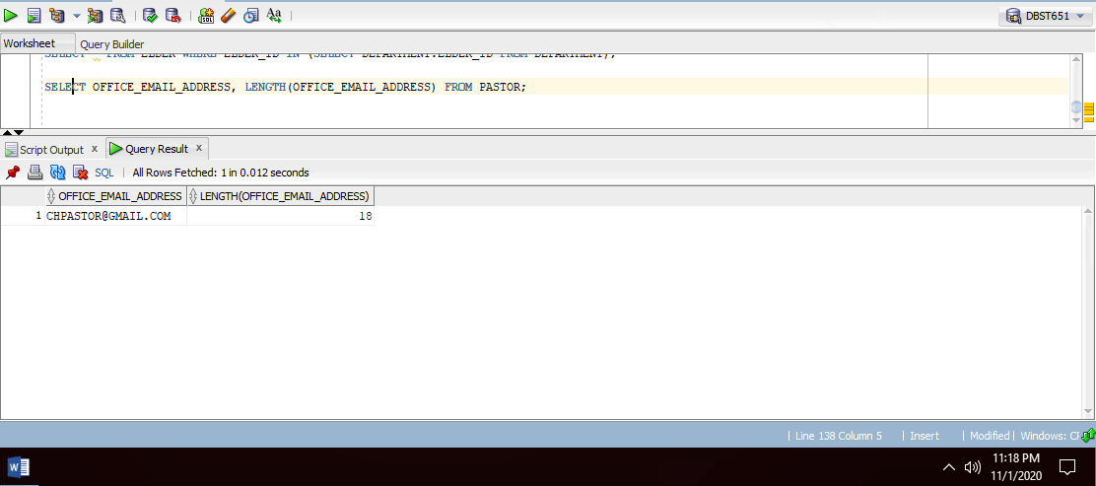

11.

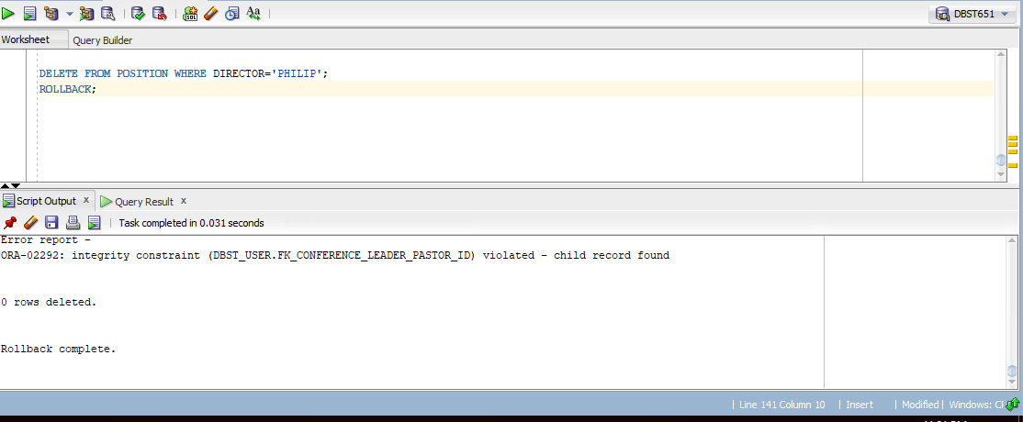

12. 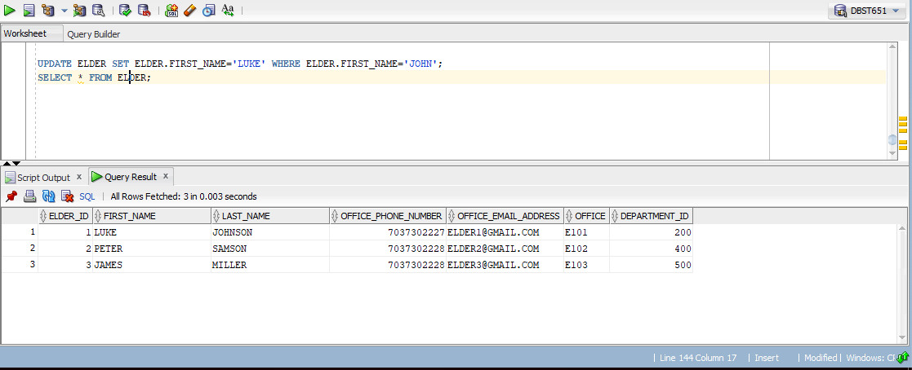

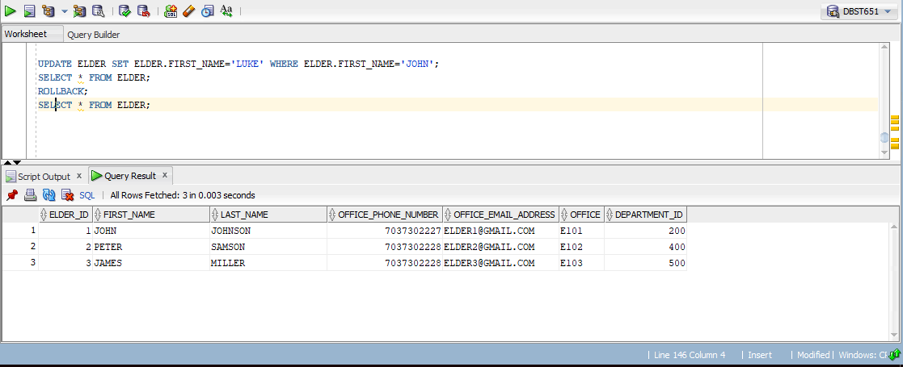

13.

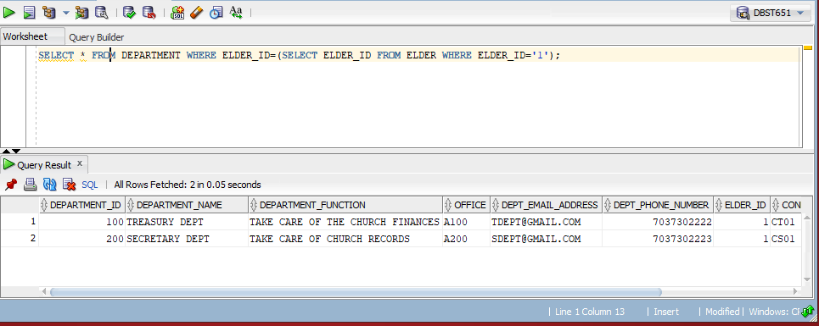

14.

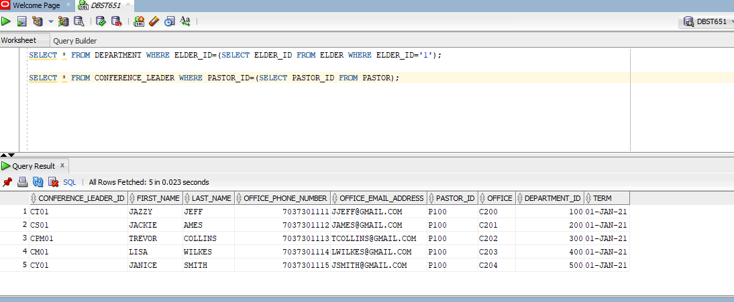

15.

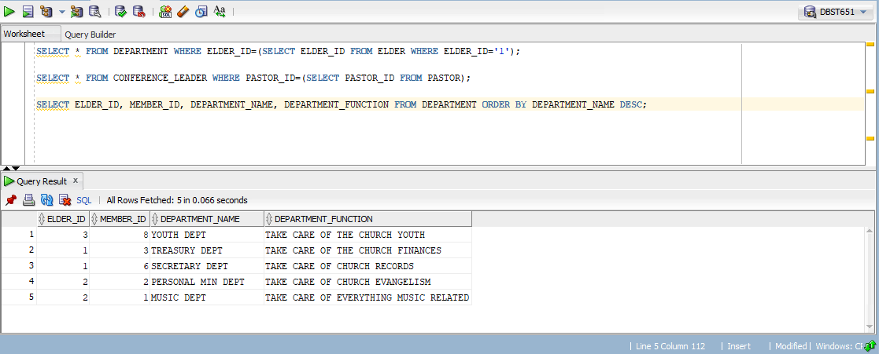

16.

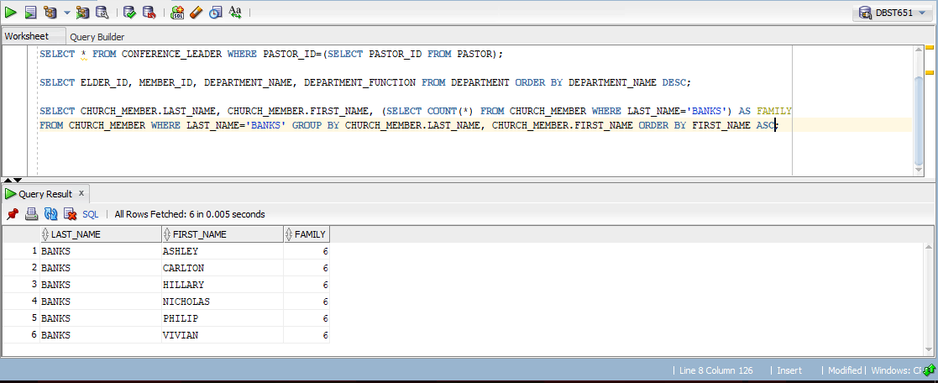

17.

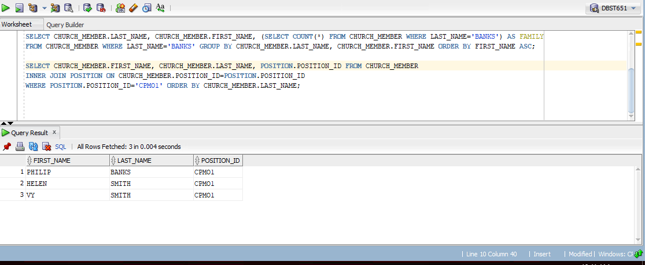

18.

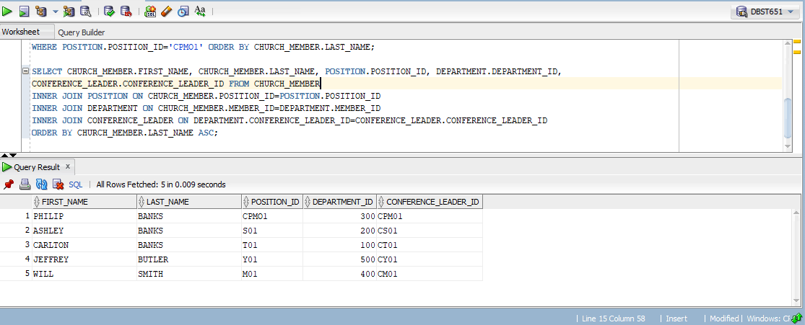

19.

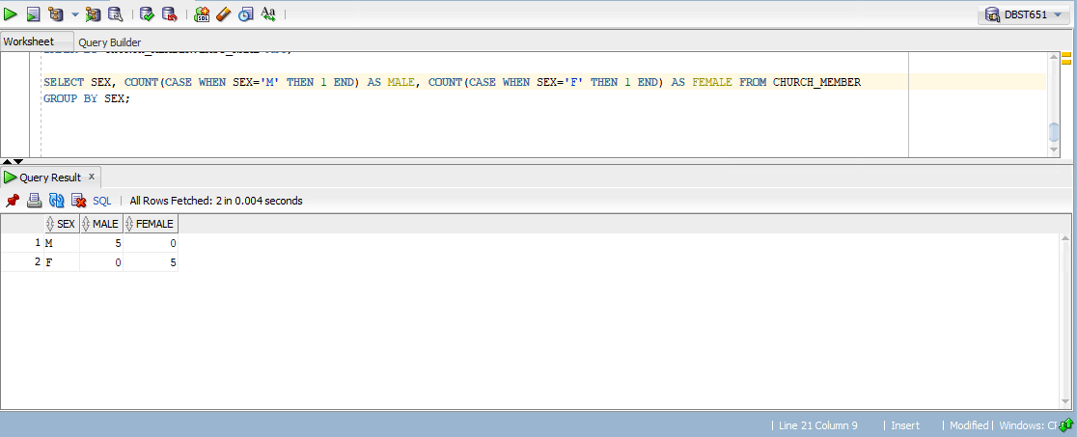

20.

